**CHARTOOL USER GUIDE**

**Suggested Workflow using CharTool**

**Step-by-step Guide**

The following is a step-by-step guide to using the CharTool modules and is intended to be used after both ImageJ and CharTool have been downloaded and installed. See the CharTool README.txt file for more information regarding installation. Each step is followed by a figure illustrating that step.

Charcoal fragment quantification and morphotype recording module

1. Open ImageJ and click the “Launch CharTool” option from the “More Tools” menu, which is access by clicking the double arrows on the righthand side of the ImageJ toolbar. This will make the CharTool icon appear on the ImageJ toolbar.

1. Click the CharTool icon to initiate the program’s start window. A splash screen with the CharTool logo will appear on the screen and close after 4 seconds. The main menu will then appear, providing the user with a choice of three modules to run in CharTool. To use the charcoal fragment quantification and morphotype recording module, select “Charcoal Fragment Quantification” and click [OK]. Additionally, the citation for CharTool is available in this window.

1. Select the input mode for running CharTool. These include either 1) a live video feed from a digital microscope or camera, or 2) a still image of a charcoal petri dish or slide. The following section (step 4) illustrates the setup for the live video feed from a digital microscope or camera. If using still images, select the “Still Image of Charcoal Sample” option and a file open dialog box will appear for the user to select an image to open. Once the image is open, proceed to step 5.

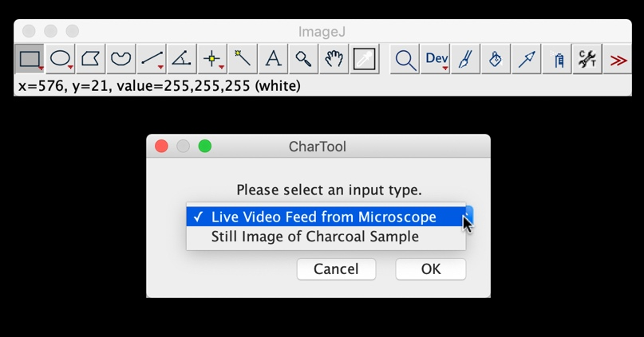

1. Click [OK] to connect to a video microscope. From the dropdown in the next window, select the desired video microscope and click [OK]. Finally, follow the last prompt window to click [OK] when the microscope is connected. It is important to wait until the microscope is connected and the live video display appears before advancing to the next steps.

1. The user may now select the option to use the module with the morphotype input option or without it.

1. CharTool will then prompt the user to install the remainder of the macros needed to run this module. The user may also at this point set the calibration measurements to quantify charcoal during the current session. This is an optional step an only needs to be performed once if the magnification settings are not going to change between sessions.

* 1. If measurements need to be set, select this option and click [OK]. CharTool will prompt the user to draw a line of a known length on the current video feed/image. Once the line is draw, click [OK], then enter in the known distance of the line in microns (µm) as indicated by the scale in the live video microscope feed/image. Click [OK]. CharTool is now calibrated. It is recommended that a microscope calibration slide or a ruler with at least 0.5 mm increments be used for this process.

* 1. An additional dialogue will ask if a visible scalebar should also be added to the live video microscope feed/image. This scale bar will reflect the scale set by the user in the previous step or the scale present from the last session.

1. A final dialogue window will outline the keyboard shortcuts used in this module for selecting charcoal fragments in the video feed/image. They are as follows:

[C] Selects the magic wand tool, which will use the edge-detecting procedure to isolate dark-valued charcoal fragments and create a selection around all connecting pixels that meet the set threshold criteria.

[X] Selects the freehand selection tool. This tool can be used to trace charcoal particles that cannot be isolated using the magic wand tool due to lighting conditions or other factors obscuring the fragment.

[Z] Activates the edge-detecting measure tool options, which displays a threshold tolerance slider that can be used to make on-the-fly corrections to the threshold value selected by the magic wand tool.

[A] Opens a dialogue to enter or reenter metadata for the sample.

[S] Displays a flowchart illustrating morphotype categories based on Enache and Cumming (2006). Intended for use when in “Morphotype Input” mode.

[D] Deletes the last measurements made.

[N] If no charcoal is found within the petri dish, this shortcut will populate a single row of measurements with zeros which can then be saved as a comma separated values file (.csv) or a Microsoft Excel file (.xlsx). All users might not find this function useful, but for those wishing to keep track of all samples analyzed, this provides a record that no charcoal was found in that particular sample.

[H] Displays these keyboard shortcuts again for reference.

[Q] Opens another image for analysis (for use in “Still Image of Charcoal Sample” mode).

[M] Once a charcoal fragment has been isolated via the magic wand tool or by freehand selection, right-clicking or pressing [M] will measure and record the fragment. If the “Morphotype Input” option was selected during setup, an additional window will appear to classify the selected charcoal fragment according to Enache and Cumming 2006. For reference, a conceptual flow chart of morphotypes is included as a .png file in the CharTool file folder.

1. To quantify charcoal fragments, select them using the magic wand tool [C] or by freehand selection [X]. The color value threshold can be adjusted on-the-fly by pressing [Z]. Once a fragment is selected, right-click and select “Measure Fragment...” or press [M] to measure and record the charcoal fragment’s metrics. Note that the default threshold value is 30.

1. After select “Measure Fragment...” or pressing [M] for the first time in this module, a dialogue window will appear with fields for the analyst to enter metadata associated with the sample. These include:
   1. Sample Number
   2. Depth Range (cm)
   3. Date
   4. Analyst (name, initials, or another identifier)
   5. Other Pertinent Information

1. Once all of the charcoal fragments in a sample have been quantified, the user closes the window containing a record of all the measurements. This will prompt a dialogue window asking the user to save the measurements and their associated metadata. The measurements can be saved as a comma separated values file (.csv) or a Microsoft Excel file (.xlsx).

Sediment color assessment module

1. As with the other modules, begin by clicking the “Launch CharTool” icon to initiate the start window. The user may choose which module to work in from this window. For the sediment color assessment module, select “Sediment Color Assessment.”

1. Select the input mode for running CharTool. These include either 1) a live video feed from a digital microscope or camera, or 2) a still image of a charcoal petri dish or slide. The following section (step 3) illustrates the setup for the live video feed from a digital microscope or camera. If using still images, select the “Still Image of Charcoal Sample” option and a file open dialog box will appear for the user to select an image to open. Once the image is open, proceed to step 4.

1. Click [OK] to connect to a video microscope. From the dropdown in the next window, select the desired video microscope and click [OK]. Finally, follow the last prompt window to click [OK] when the microscope is connected. It is important to wait until the microscope is connected and the live video display appears before advancing to the next steps.

1. A final dialogue window will outline the keyboard shortcuts used in this module for selecting charcoal fragments in the video feed/image. They are as follows:

[R] Creates a dialog where the current sample number can be entered by the user. Once sample is entered, the module will measure the mean RBG values for any selected area within the live video microscope feed/image. The sample number and the mean RGB values are copied over to the results table.

[D] Deletes the last measurements made.

[H] Displays these keyboard shortcuts again for reference.

[Q] Opens another image for analysis (for “Still Image of Charcoal Sample” mode only).

1. The default setting for this module is to select the rectangle selection tool on setup. When assessing the color of a sediment sample, use the rectangle selection tool to select a region of the sample. Press [R] to record mean RBG values for the pixels within the selection.

1. Each time the user presses [R] to record RGB values, a dialogue window will appear with fields for the analyst to enter metadata associated with the sample. These include:
   1. Sample Number
   2. Depth Range (cm)
   3. Date
   4. Analyst (name, initials, or another identifier)
   5. Other Pertinent Information

1. RGB values for each selection will be copied over to the results table along with the user supplied metadata for each sample. The results table can be saved as a comma separated values file (.csv) or a Microsoft Excel file (.xlsx) by closing the window and following the save prompts.

Expedient sediment grain size estimation module

1. As with the other modules, begin by clicking the “Launch CharTool” icon to initiate the start window. The user may choose which module to work in from this window. For the sediment color assessment module, select “Grain Size Evaluation.”

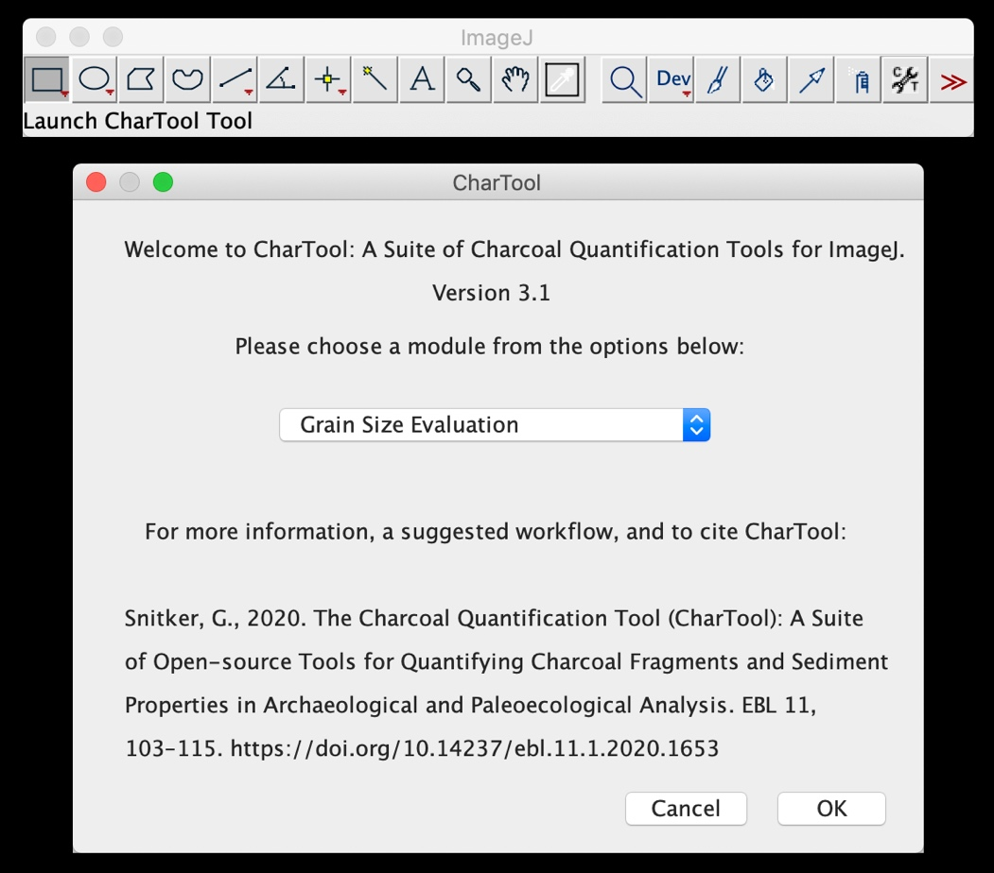

1. Click [OK] to connect to a video microscope. From the dropdown in the next window, select the desired video microscope and click [OK]. Finally, follow the last prompt window to click [OK] when the microscope is connected. It is important to wait until the microscope is connected and the live video display appears before advancing to the next steps. Please note that this module is only available using a video microscope.

1. CharTool will then prompt a window for the user to install the remainder of the macros needed to run this module. The user may also at this point set the calibration measurements to quantify charcoal during the current session. This is an optional step an only needs to be performed once if the magnification settings are not going to change between sessions.
   1. If measurements need to be set, select this option and click [OK]. CharTool will prompt the user to draw a line of a known length on the current video feed. Once the line is draw, click [OK], then enter in the known length of the line and the units. Click [OK]. CharTool is now calibrated. It is recommended that a microscope calibration slide or a ruler with at least 0.5 mm increments be used for this process.

* 1. An additional dialogue will ask if a visible scalebar should also be added to the live video microscope feed. This scale bar will reflect the scale set by the user in the previous step or the scale present since the last session.

1. A final dialogue window will outline the keyboard shortcuts used in this module for selecting charcoal fragments in the video feed. They are as follows:

[S] Activates the workflow for assessing the diameter of individual grain sizes within a sediment sample. See details on this process below.

[D] Deletes the last measurements made.

[H] Displays these keyboard shortcuts again for reference. For additional reference, a .png image of the US Geological Survey Wentworth Scale is included in the CharTool file folder to aid in interpreting grain size results.

1. The default setting for this module is to select the rectangle selection tool on setup. When assessing particle size in a sediment sample, use the rectangle selection tool (or any other selection tool available for ImageJ) to select a region of the sample in the live video microscope feed. Press [S] to begin the particle size evaluation workflow.
   1. The first dialogue that appears will ask the user to set the minimum number of observations needed to adequately represent the current sediment sample and the minimum area of a particle for it to be measured. The default values for these two parameters are 300 (minimum observations) and 4,000 (minimum area in current units), but they should be adjusted to appropriate values for the needs of the current user or project. Click [OK] to advance through this dialogue window.

* 1. The module then creates a still frame duplicate of the select area within the video feed. This still frame duplicate is converted to an 8-bit, black and white image to which a color value threshold is applied to isolate individual particles. An interactive threshold dialogue is activated, which allows the user to adjust the cut off value with the goal of isolating as many particles as possible. The areas of the image obscured by a red mask are those included within the threshold while those without the mask are excluded. Unlike the thresholds applied during the charcoal quantification module, these values will likely be much lower and incorporate a wider range of sediment grains. It is helpful to place sediment in a petri dish on a white background (such as a sheet of white paper) to allow the sediment grains to be differentiated from the background.
  2. Once an adequate threshold is reached, click [OK] in the dialogue that asks “Threshold set?” to measure each individual particle and recording the measurements in the results table. If fewer measurements are made than the minimum number of observations set at the beginning of this workflow, the module will ask for another selection to be made and the process of thresholding and measuring particles will repeat. This workflow will continue until the minimum number of observations are met.

1. After pressing [S] to activate the grain size workflow in this module, a dialogue window will appear with fields for the analyst to enter metadata associated with the sample. These include:
   1. Sample Number
   2. Depth Range (cm)
   3. Date
   4. Analyst (name, initials, or another identifier)
   5. Other Pertinent Information
2. Once the minimum number of particles in a sample have been measured, the user closes the window containing a record of all the measurements and their associated metadata. This will prompt a dialogue window asking the user to save the measurements. The measurements can be saved as a comma separated values file (.csv) or a Microsoft Excel file (.xlsx).

**Scripted R Analysis to compile, display, and prepare CharTool outputs for upload into the Global Paleofire Database (GPFD)**

The R script and RStudio Project file used to compile and display metrics collected by CharTool is included in the CharTool .zip folder available on via GitHub (<https://github.com/gsnitker/CharTool>) or directly via the following url:

<https://github.com/gsnitker/CharTool/tree/master/CharTool_R_scripts>

The versions of R, RStudio, and all required packages used in this scripted analysis are included in the header section of the R script.

**Citing CharTool**

Please use the following citation for CharTool:

Snitker, G., 2020. The Charcoal Quantification Tool (CharTool): A Suite of Open-source Tools for Quantifying Charcoal Fragments and Sediment Properties in Archaeological and Paleoecological Analysis. EBL 11, 103–115. <https://doi.org/10.14237/ebl.11.1.2020.1653>